ST.ANN’S COLLEGE OF ENGINEERING & TECHNOLOGY
DEPARTMENT OF ELECTRICAL AND ELECTRONICS ENGINEERING

(Accredited Twice by NBA & IE(I) & NAAC With ‘A’ GRADE approved by AICTE , New Delhi & Permanently affiliated to J.N.T.U KAKINADA, Kakinada) Nayunipalli,
Vetapalem, Chirala -523187
2010-2014
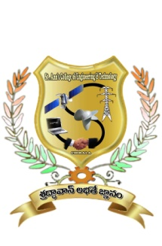

CERTIFICATE

This is to certify that the project report entitled “ POWER UPGRADING OF TRANSMISSION LINE BY INTEGRATED AC-DC TRANSMISSION” is the bonafide work done by Ms./Mr.____________________ with Regd no:________________ submitted in the partial fulfillment of the requirements for the award of Bachelor of Technology in ELECTRICAL & ELECTRONICS ENGINEERING of Jawaharlal Nehru Technology University ,Kakinada during the academic year 2010-2014.

Viva Voce date:---------------------------------------

Project Guide Head of the Department
Mr.G.KALADHAR, M.Tech,(PhD) Mr.S.V.D.ANILKUMAR,M.Tech(PhD-)
Assistant Professor, Department of EEE, Associate Professor, Department of EEE,

Signature of External Examiner

DECLARATION

I hereby declare that the project entitled, “POWER UPGRADING OF TRANSMISSION LINE BY INTEGRATED AC-DC TRANSMISSION” was carried out and written by us under the guidance of Mr .G.KALADHAR, M.Tech (Ph.D),Assistant Professor of Electrical and Electronics Engineering, St. Ann’s College of Engineering & Technology, Chirala. This work has not been previously formed the basis for the award of any degree or diploma or certificate nor has been submitted elsewhere for the award of any degree or diploma.

Place: G.AMULYA
DATE: (10F01A0236)

